Automated Onboarding Checklist Generator
Problem 7 – Feature Set C
3rd-Year AI-Based Assignment
A simple web application that automatically generates an onboarding checklist for a new employee based on the selected role and department, and allows users to track the completion progress.

Features
1. Role/Department Selection
- Select an employee role from a dropdown.
- Select a department from a dropdown.
- Validation is provided for both selections.
- Checklist is generated according to the selected role and department.
2. Automatic Checklist Generation
- The Express.js API generates the onboarding checklist.
- The checklist contains:
  - Common onboarding tasks
  - Role-specific tasks
  - Department-specific tasks
- Tasks are automatically returned by the backend API.
3. Display Tasks
- Display all generated onboarding tasks.
- Each task has a checkbox.
- Show task status as:
  - Pending
  - Completed
- Completed tasks can be unchecked again.
4. Progress Dashboard
The dashboard displays:
- Total tasks
- Completed tasks
- Remaining tasks
- Completion percentage
- Progress bar
The dashboard updates instantly whenever a task is checked or unchecked.

Technology Stack
Frontend
- HTML5
- CSS3
- JavaScript
Backend
- Node.js
- Express.js

Project Structure
onboarding-checklist/
│
├── backend/
│ ├── server.js
│ └── package.json
│
├── frontend/
│ ├── index.html
│ ├── style.css
│ └── script.js
│
├── screenshots/
│ ├── home-page.png
│ ├── role-department.png
│ ├── checklist.png
│ └── progress-dashboard.png
│
└── README.md

How to Run
1. Open the Project
Open the project folder in Visual Studio Code.
2. Open Terminal
Navigate to the backend folder:
cd backend
3. Install Dependencies
npm install
4. Start the Server
npm start
5. Open the Website
Open your browser and visit:
http://localhost:3000

API
Generate Checklist
GET /api/checklist?role=Developer&department=IT
Example Request
http://localhost:3000/api/checklist?role=Developer&department=IT
Example Response
{
"role": "Developer",
"department": "IT",
"tasks": [
"Complete HR documentation",
"Set up development environment",
"Meet the development team"
]
}
Error Response
If the role or department is missing or unknown, the API returns HTTP 400.
{
"error": "Role and department are required"
}

How It Works
- The user selects a Role.
- The user selects a Department.
- The frontend validates the selections.
- JavaScript sends the selected values to the Express.js server using fetch().
- The backend combines:
  - Common tasks
  - Role-specific tasks
  - Department-specific tasks
- The server returns the checklist as JSON.
- The frontend displays the generated tasks.
- The user can mark tasks as completed or pending.
- The progress dashboard automatically calculates the progress.
- The progress bar updates instantly.

Website Screenshots
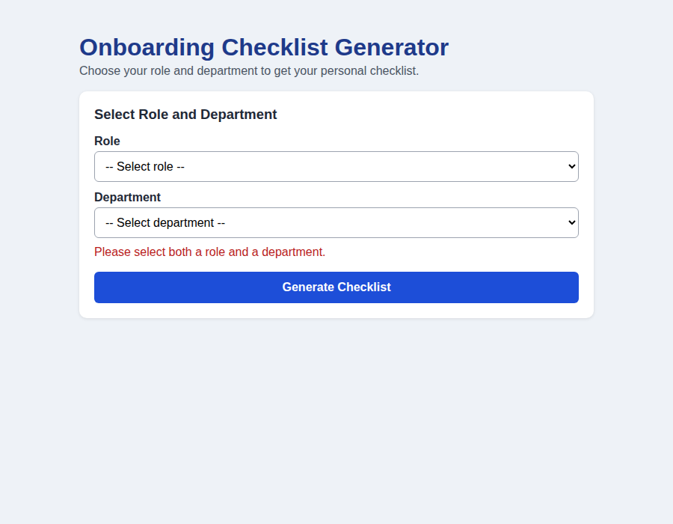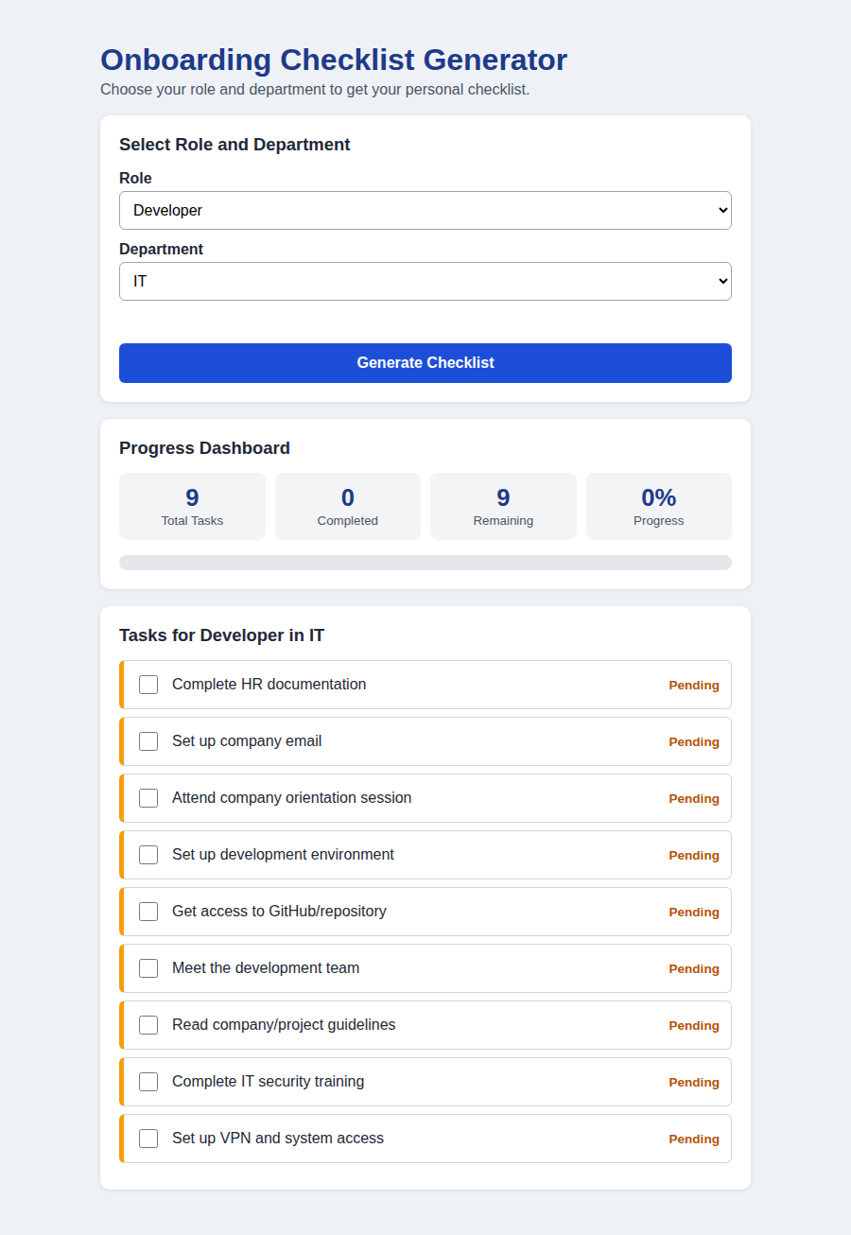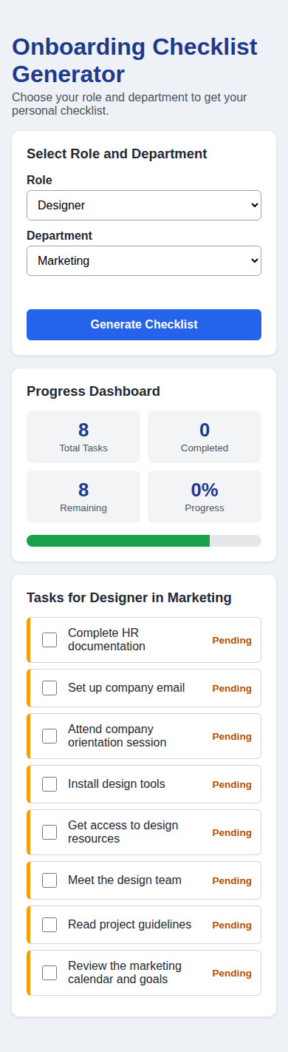
Validation
The application validates:
- Role selection
- Department selection
- Missing role or department
- Unknown role or department
- API errors
Friendly error messages are displayed when invalid input is provided.

Objective
The main objective of this project is to simplify the employee onboarding process by automatically generating customized onboarding tasks based on the employee's role and department, while providing a simple dashboard to track task completion.

Conclusion
The Automated Onboarding Checklist Generator provides an easy and efficient way to create customized employee onboarding checklists and monitor onboarding progress using a simple and responsive web interface.

